Yolanda Mason CSC 4111 Assignment 5-Unit Testing

In this assignment I will be doing unit testing on some of the methods in my codes. Unit testing is the last layer of the testing hierarchy but is very important because it checks the functionality of your program. XUNIT is a form of Unit Testing and some of the frameworks used are: PHPUnit for PHP and XUnit.js for JavaScript. These are some of the frameworks that the group I am in decided to use. The reasoning is because my group has a large number of html incorporated in the creation of the website which has PHP and java script included. I will also perform manual testing for the parts of the programs that do not use javascript or php. In this assignment I will be testing the Login page and the User Info page to check if it is functioning appropriately and if it is not what changes I may have to do to the programs to make it function. If you need me to redo the testing and use a different testing please let me know.

As previously stated in prior emails I am unable to create branches on my group’s GitHub page so I will be using a branch from my personal GitHub page until the problem can be fixed. The URL for this branch is: github.com/ymason48/Expense-Tracker

These are the test case scenarios:

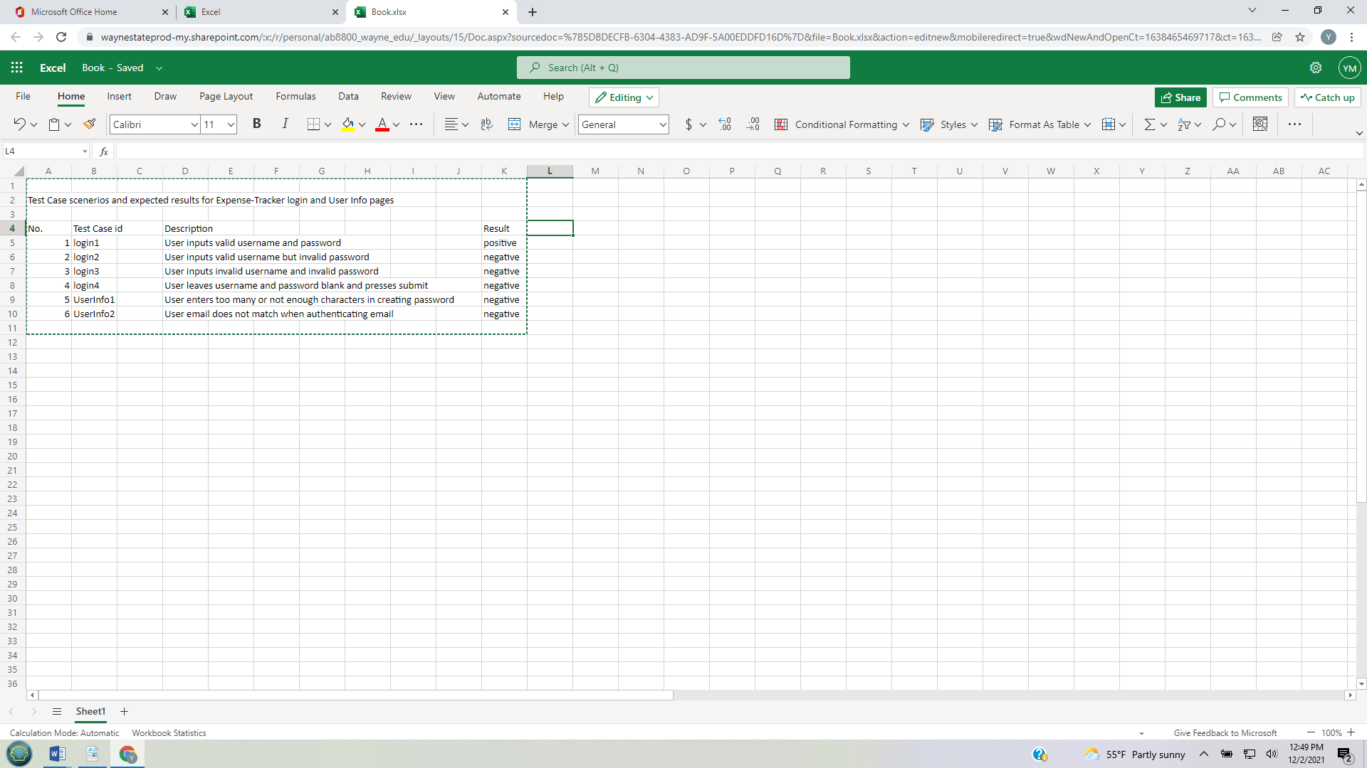

These are the screenshot images:

Test case login1:

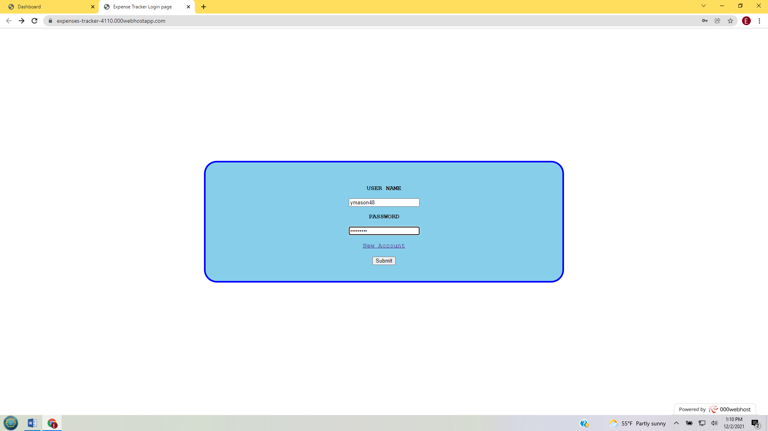

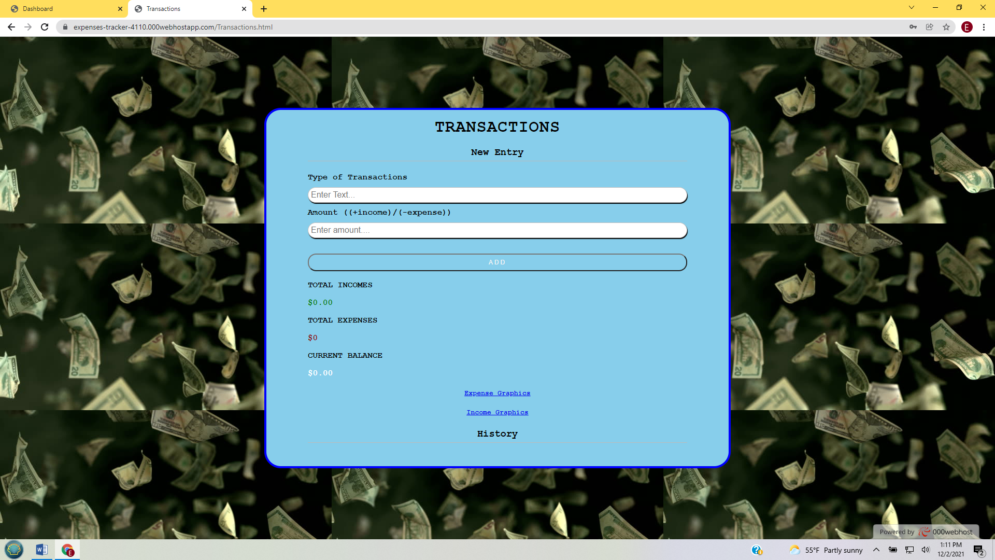

It was successful and went to the user’s personal page.

Test case login2:

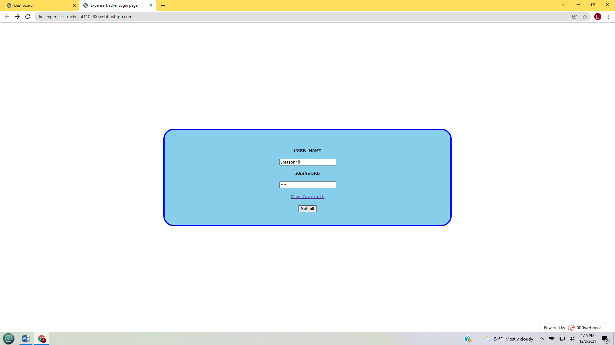

There was supposed to be an error message but it did not occur and it still went to the user personal page that is seen in the above screenshot. This will have to be fixed.

Test case login3:

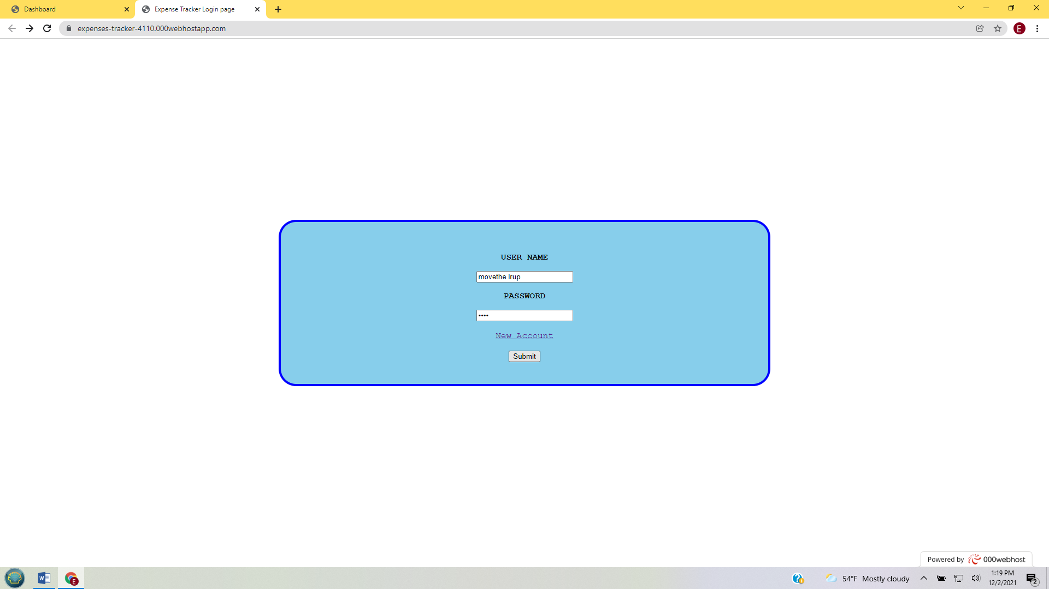

As noticed in the previous test case enough the username and password are both wrong it still went to the user personal page. The code will need to be fixed on the security end to make sure this does not happen again.

Test case login4:

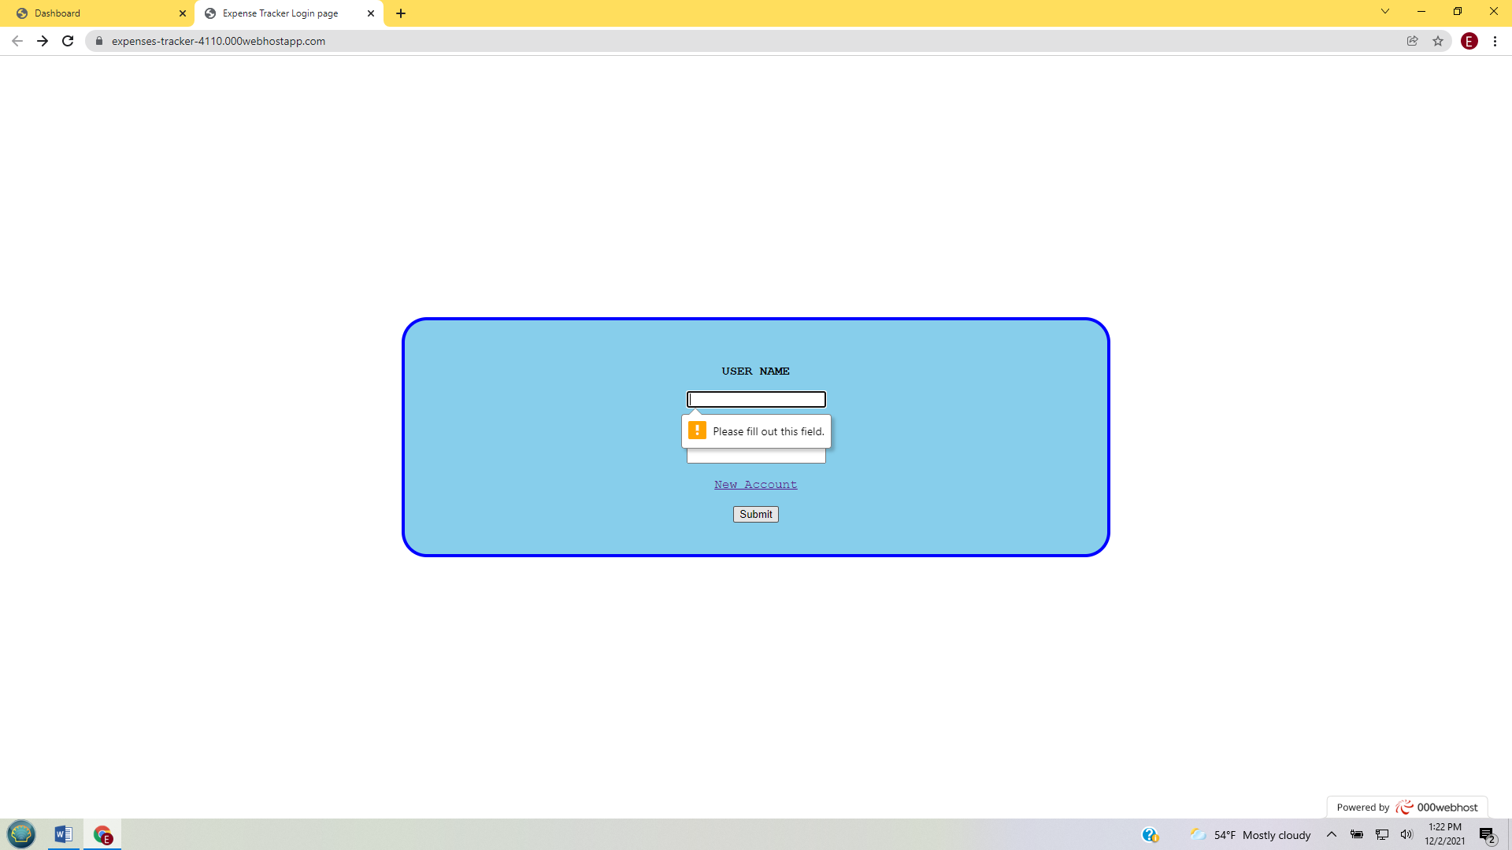

The code did work and would not connect to the user personal page. It showed an error message.

Test case UserInfo1:

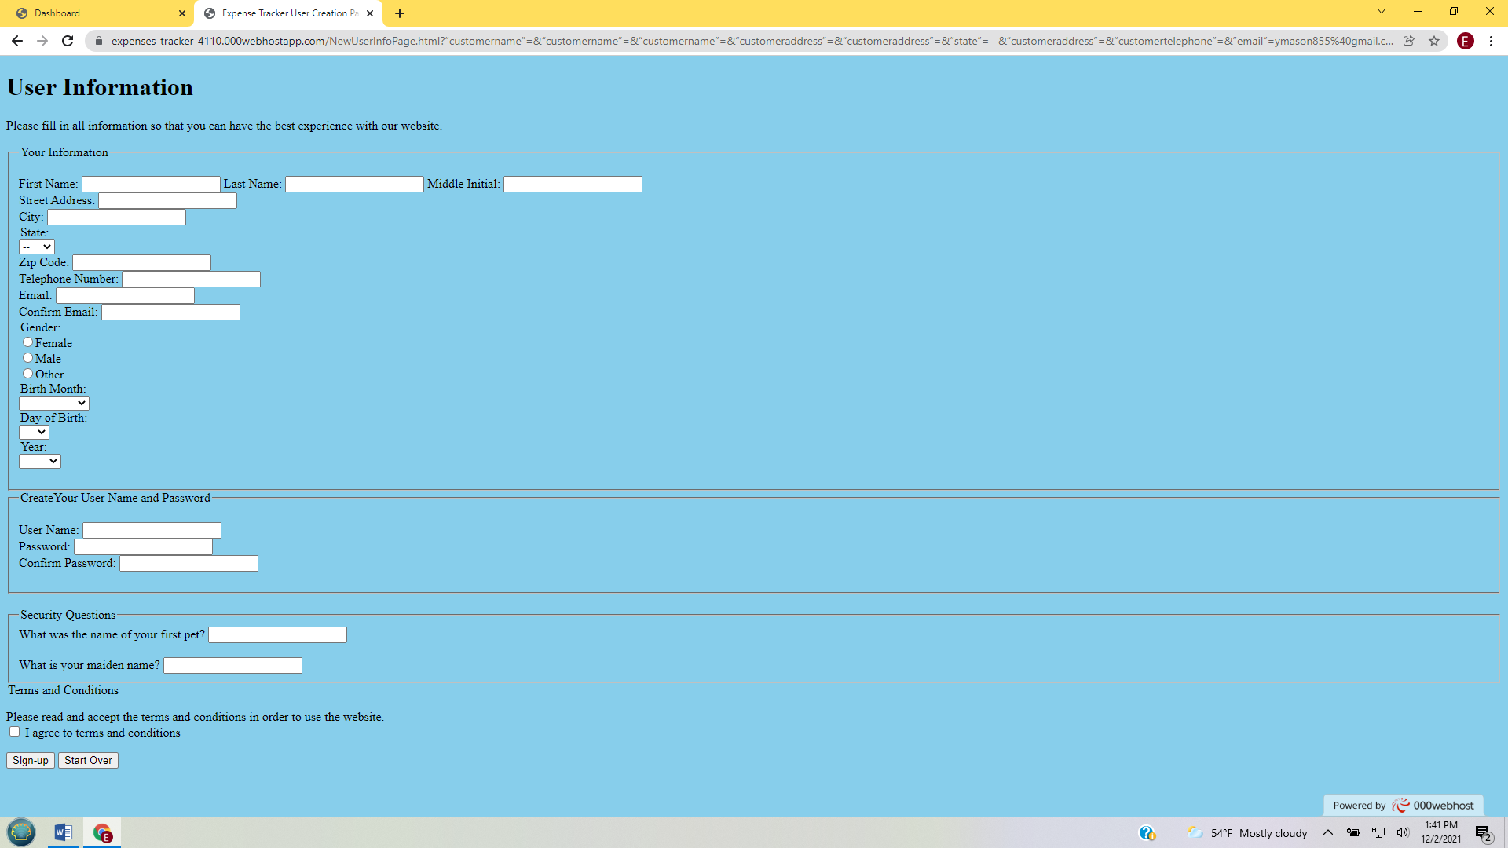

When putting in the information and clicking the sunup button it did not work, will have to fix issue No error message occurred it just erased the information.

Test case UserInfo2:



The same problem occurred that happened in the previous test. The information was erased and no error message occurred. I believed that the stipulations for these two areas need to be re-written.

After doing the testing I have discovered that I will need to go back into the program and create more codes to help with the minimum and maximum number of characters and also special characters or the username, password and setting up of the email address. I also will be adding node.js to the login page to help with security. I believe that this will solve the problems with these codes. The unit testing I did met all the standards for good testing except for the first which is that the testing should be automatic which means it should be totally run by a computer with no human interaction and since I had to manual test there was some human interaction. However, I do believe that I did do the other methods which are: atomic, single responsibility, independent and repeatable.